Dear Class,
I have tested the below mentioned steps in order for you to search the syntax with the help of google search engine. We have enabled the rules so that you will have access to limited websites.
But you can tap into the google search engine and get the results from geeksforgeeks and stackoverflow.

Search : Example ”how to set the title in seaborn”
Type search in google home page using chrome browser
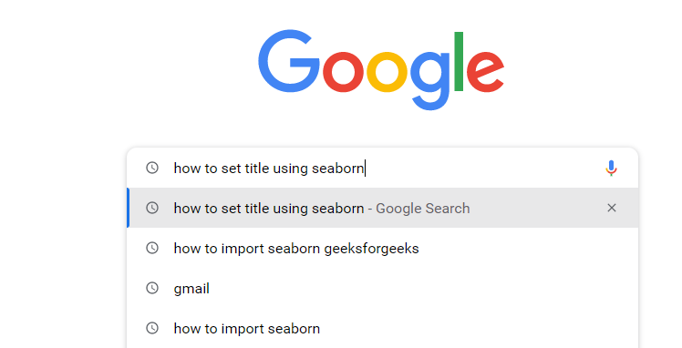

Pick the results from allowed websites( geeksforgeeks, stackoverflow)
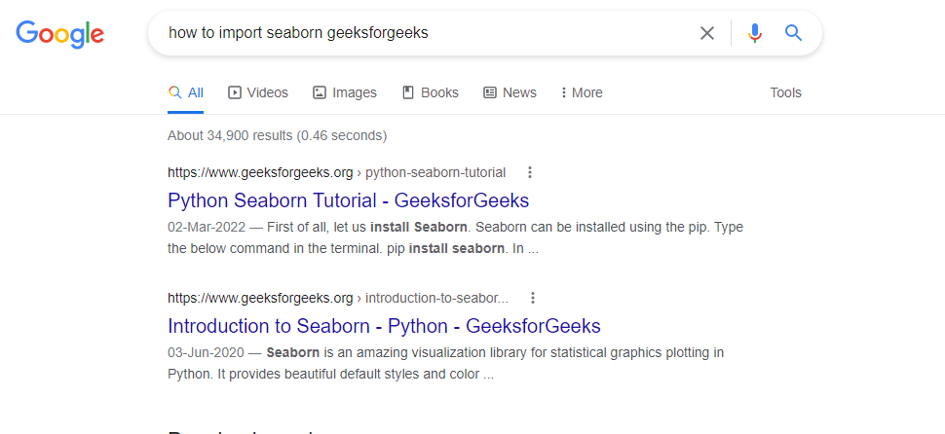

Open the link that best fits

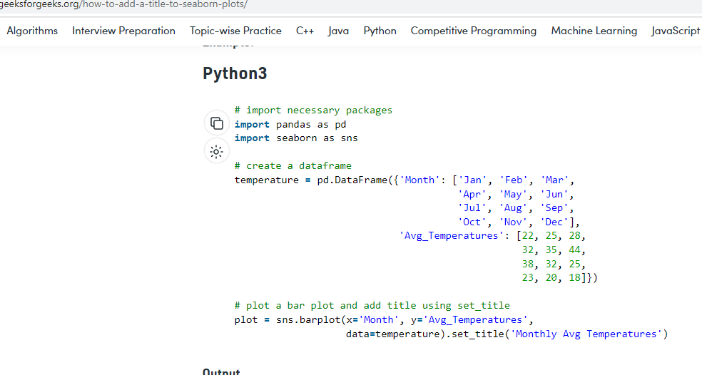

All the best !

